Step 1: Go to Myget feed

<https://www.myget.org/feed/Packages/bigatad>

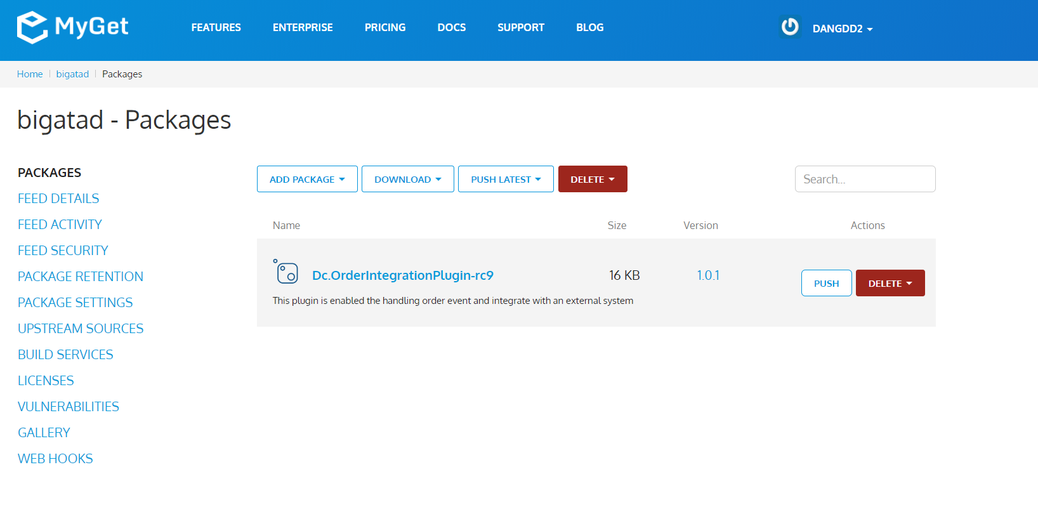

Step 2 : Copy Nuget NPM command

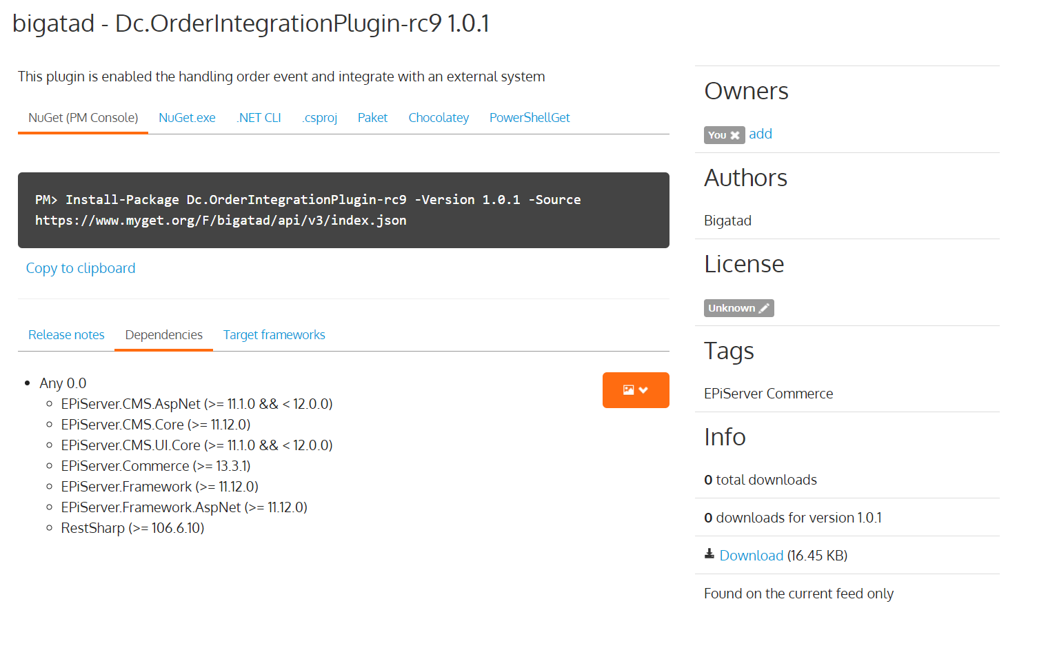

Step 3: run it on Visual Studio Package Manage Console

Install-Package Dc.OrderIntegrationPlugin-rc10 -Version 1.0.1 -Source https://www.myget.org/F/bigatad/api/v3/index.json

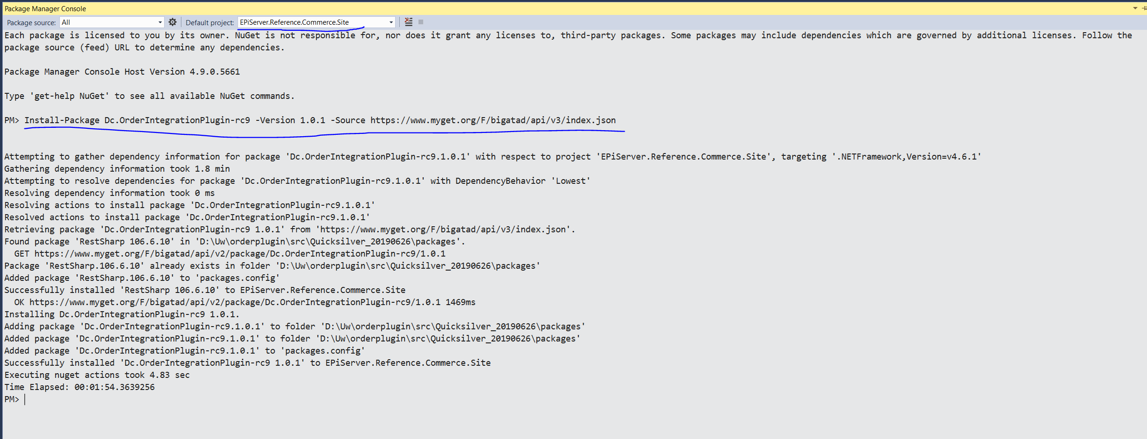Step 4: Set the order rest api value

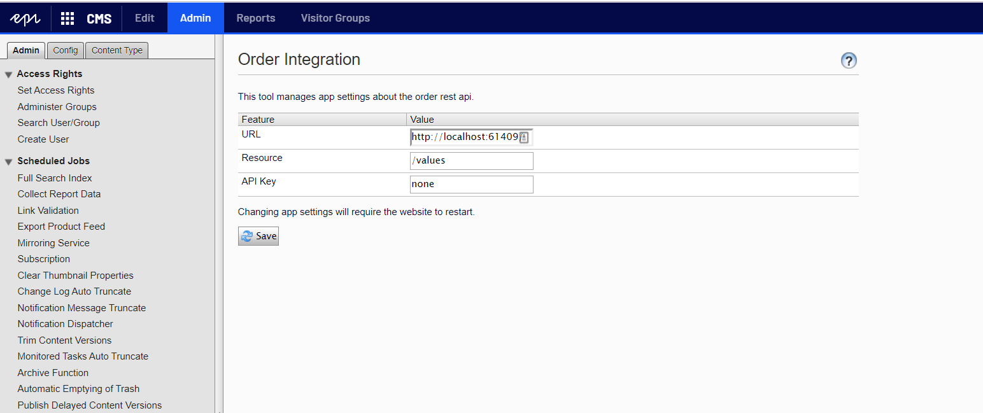

Step 5: Check the result

